**8-Bit Arithmetic Operations using 8085**

**Aim:**

To perform 8-bit arithmetic operations such as addition, subtraction, multiplication, and division using the 8085 microprocessor.

**Apparatus Required:**

* Laptop with internet connection

**Algorithm:**

**For Addition (With Carry Consideration):**

* Load the first number into register A.
* Load the second number into register B.
* Add the contents of registers A and B.
* If carry is generated, store carry in a separate location.
* Store the sum in another location.

**For Subtraction (Considering Greater Number):**

* Load the first number into register A.
* Load the second number into register B.
* Compare A and B.
* If A < B, swap the values of A and B to ensure positive result.
* Subtract the content of B from A.
* Store the result in a specified location.

**For Multiplication:**

* Load the first number into register A.
* Load the second number into register B.
* Multiply A and B using repeated addition.
* Store the result in suitable locations (including extra space if needed for higher bits).

**For Division:**

* Load the dividend into register A.
* Load the divisor into register B.
* Perform division using repeated subtraction.
* Store the quotient in one location and remainder in another.

**Program:**

Addition of Two 8-bit Numbers:

IN 01H ; Read first number into A

MOV B, A ; Store it in B

IN 02H ; Read second number into A

ADD B ; A = A + B

OUT 03H ; Output sum to port 03H

MVI C, 00H ; Clear C register

JNC SKIP_CARRY ; Jump if no carry

INR C ; If carry occurred, C = 1

SKIP_CARRY:

MOV A, C

OUT 04H ; Output carry to port 04H

Subtraction (First number - Second number)

IN 01H ; Read first number into A

MOV B, A ; Store in B

IN 02H ; Read second number into A

MOV C, A ; Store in C

MOV A, B ; A = first number

SUB C ; A = A - second number

OUT 05H ; Output result to port 05H

HLT ; End of program

Multiplication using repeated addition:

IN 01H ; Read first number (Multiplicand) into A

MOV C, A ; Store in C

IN 02H ; Read second number (Multiplier) into A

MOV B, A ; Store in B

MVI A, 00H ; Clear A to hold result

LOOP:

ADD C ; A = A + C

DCR B ; B = B - 1

JNZ LOOP ; Repeat until B = 0

OUT 06H ; Output the result to port 06H

HLT ; End of program

Division (Using Repeated Subtraction):

IN 01H ; Read dividend into A

MOV C, A ; Store dividend in C (for remainder tracking)

MVI A, 00H ; Clear A for quotient

MOV D, A ; Use D to store quotient

IN 02H ; Read divisor into A

MOV B, A ; Store divisor in B

DIV_LOOP:

MOV A, C ; Load current remainder into A

CMP B ; Compare remainder with divisor

JC END_DIV ; If A < B, jump to END_DIV

SUB B ; A = A - B

MOV C, A ; Update remainder in C

INR D ; Increment quotient

JMP DIV_LOOP ; Repeat loop

END_DIV:

MOV A, D ; Move quotient to A

OUT 03H ; Output quotient to port 03H

MOV A, C ; Move remainder to A

OUT 04H ; Output remainder to port 04H

HLT ; End program

**Output:**

Addition of Two 8-bit Numbers:

**Input Ports:**

* **01H** → First number
* **02H** → Second number

**Output Ports:**

* **03H** → Sum
* **04H** → Carry (if generated)

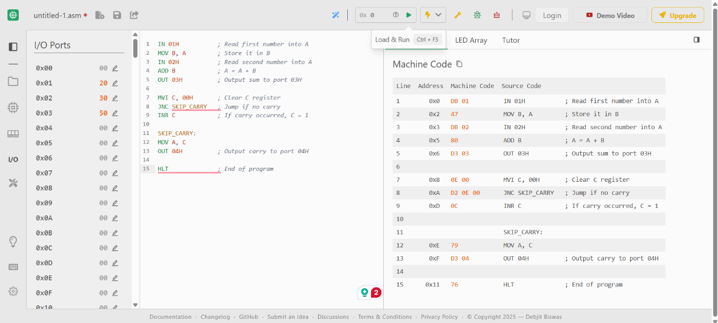

Subtraction (First number - Second number)

**Input Ports:**

* **01H** → First number
* **02H** → Second number

**Output Ports:**

* **05H** → Result (Difference)

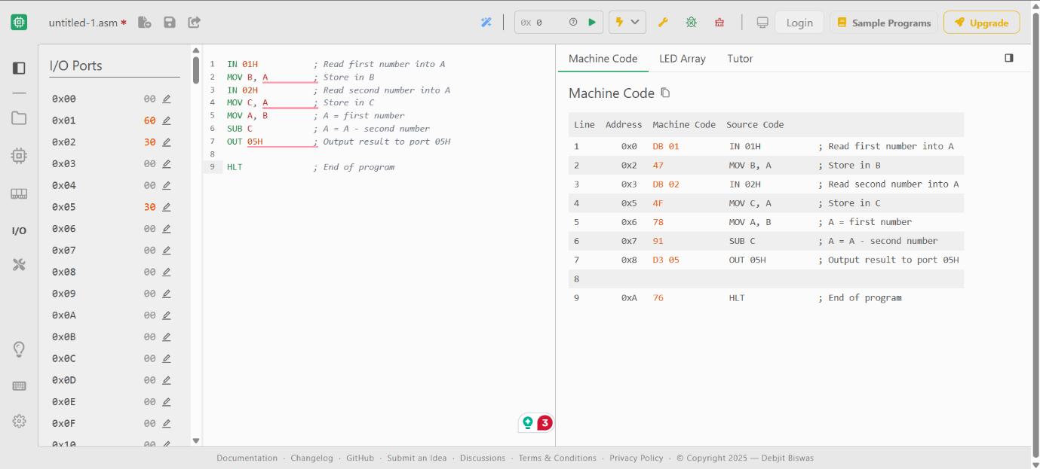

Multiplication using repeated addition:

**Input Ports:**

* **01H** → Multiplicand
* **02H** → Multiplier

**Output Ports:**

* **06H** → Product

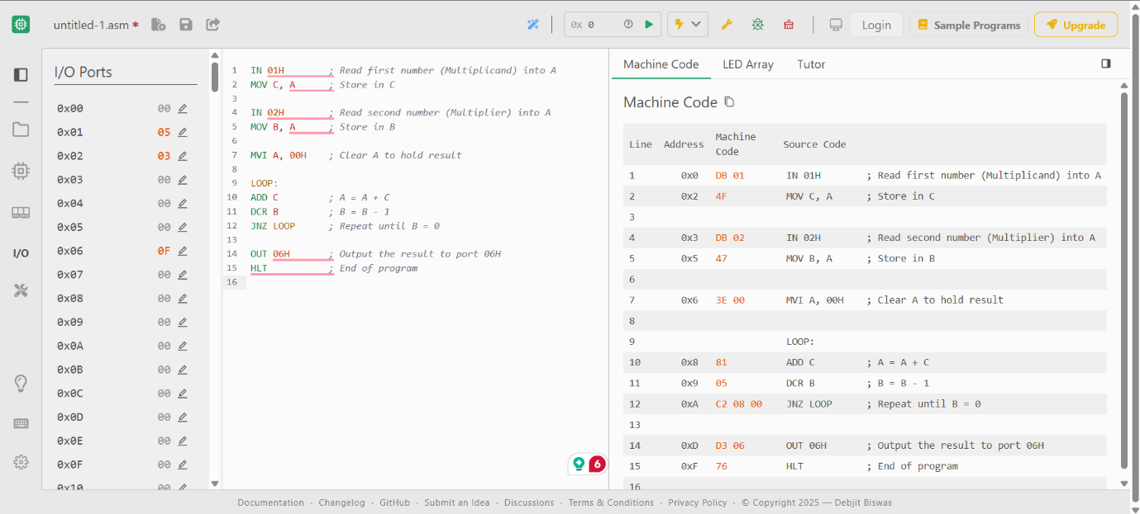

Division (Using Repeated Subtraction):

**Input Ports:**

* **01H** → Dividend
* **02H** → Divisor

**Output Ports:**

* **03H** → Quotient
* **04H** → Remainder

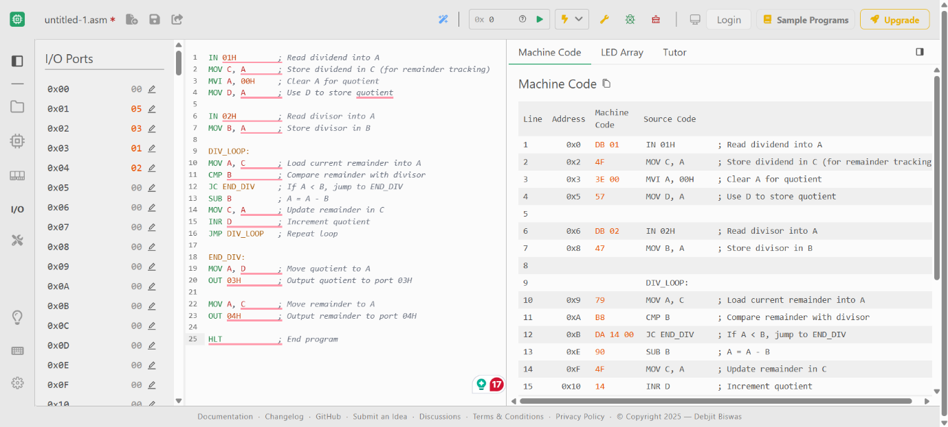

**Result:**

The 8-bit arithmetic operations using the 8085 microprocessor have been successfully executed and verified using memory access for input and output.